**Cloud Computing Assignment: 4**

**Title** :- Implementation of Virtualization in Cloud Computing to Learn Virtualization Basics,

Benefits of Virtualization in Cloud using Open Source Operating System. (Docker).

**Objective** :- From this experiment, the students will be able to,

* Understand the concepts of building, deploying and managing applications on Docker.
* Understand Docker interface,its commands and implement on playwithdocker.com

**Problem Statement** :- To understand the basic commands, its platform how its works,

configuration of its instances by creating and deploying applications

on both ubuntu terminal as well as playwithdocker.com.

**Outcomes** :-

* + Students will be able to easily build, debug and deploy apps on docker terminal.
  + By using dockerHub, one gets to know the container movement from and to the instance.
  + One will get to know the various types of commands used in docker for various uses.

**Software and Hardware Requirements** :- (**DOCKER**)

* Software:- Windows/Linux Operating System, DockerHub Account
* Hardware:- Nil

**Theory**:-

[Docker](https://github.com/docker/docker) is a tool designed to make it easier to create, deploy, and run applications by using containers. Containers allow a developer to package up an application with all of the parts it needs, such as libraries and other dependencies, and deploy it as one package. By doing so, thanks to the container, the developer can rest assured that the application will run on any other Linux machine regardless of any customized settings that machine might have that could differ from the machine used for writing and testing the code.

In a way, Docker is a bit like a virtual machine. But unlike a virtual machine, rather than creating a whole virtual operating system, Docker allows applications to use the same Linux kernel as the system that they're running on and only requires applications be shipped with things not already running on the host computer. This gives a significant performance boost and reduces the size of the application.

And importantly, Docker is [open source](https://opensource.com/resources/what-open-source). This means that anyone can contribute to Docker and extend it to meet their own needs if they need additional features that aren't available out of the box.

Docker is a tool that is designed to benefit both developers and system administrators, making it a part of many DevOps (developers + operations) toolchains. For developers, it means that they can focus on writing code without worrying about the system that it will ultimately be running on. It also allows them to get a head start by using one of thousands of programs already designed to run in a Docker container as a part of their application. For operations staff, Docker gives flexibility and potentially reduces the number of systems needed because of its small footprint and lower overhead.

**Program Codes with Output Screenshots**:- <**DOCKER COMMANDS IMPLEMENTED ON**

**PLAYWITHDOCKER.COM>**

**Screenshots:-**

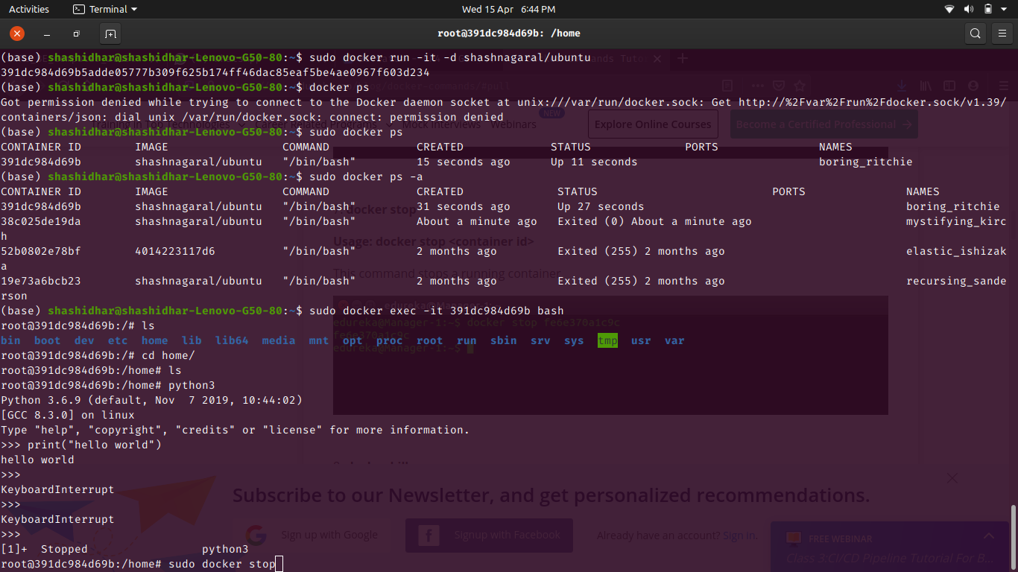

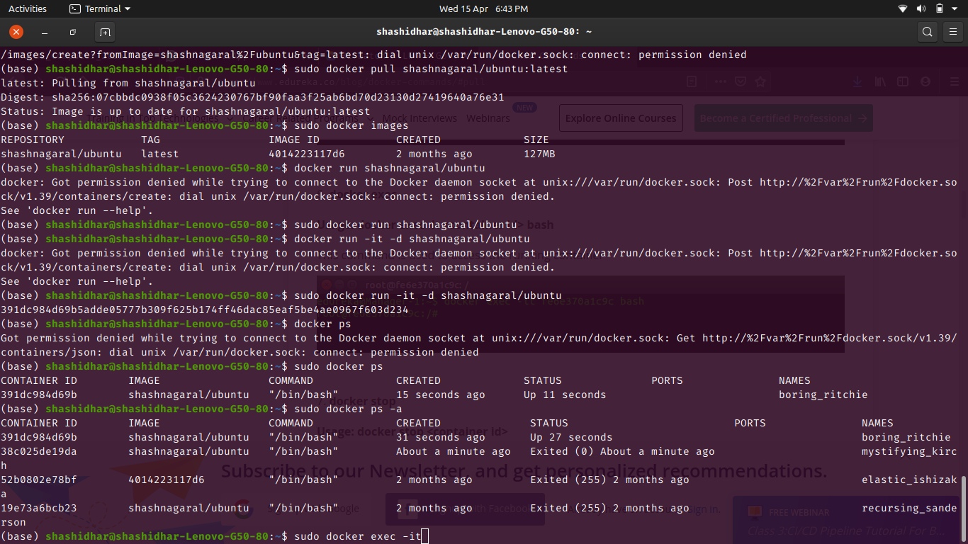

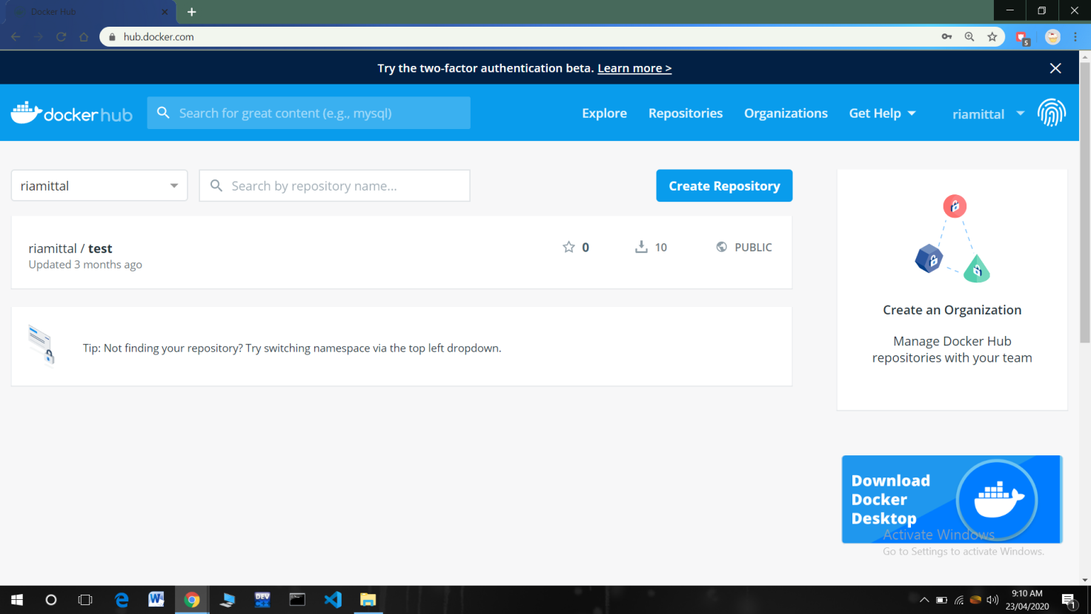

**Conclusion**:- Students were able to get themselves hands-on experience on docker interface,

understanding lots of commands and also gained knowledge about implentation of a

cloud application.